General Introduction

In order to ensure the financial health of the project and to achieve the financial objectives originally defined for the project, the Project Accounting System is introduced. It offers complete tracking facilities to help track and manage the cost / expense issues of the project during its delivery life cycle.

The web address for user to get access into PAS in office is http://192.168.2.4/Live, and the training address is http://192.168.2.4/Train which is built for user to practice. For the staffs who are not in the office may get access into PAS with http://220.248.47.39/Live, also the practice address is http://220.248.47.39/Train.

The diagram 1 is the logon screen, Please log into PAS with your staff ID (like CN00000) and the default password is lowercase “password”, it is case-sensitive.

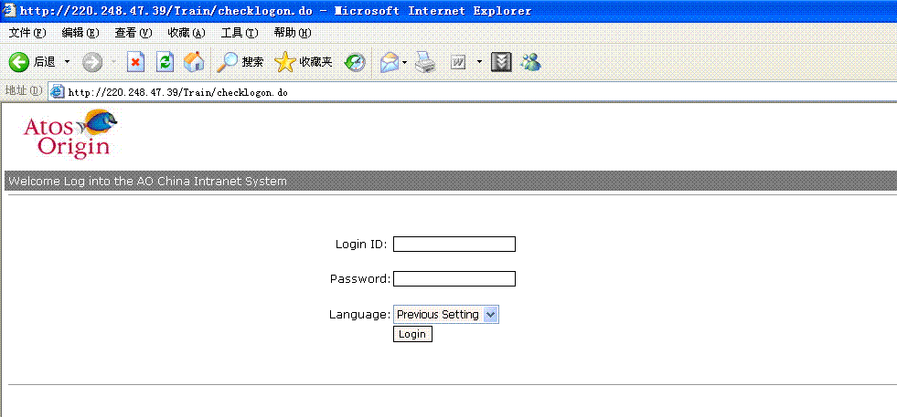
Diagram 1: log on page

When you get access into the PAS home page (diagram 2), you may change your password by click the key icon at right top of the screen.
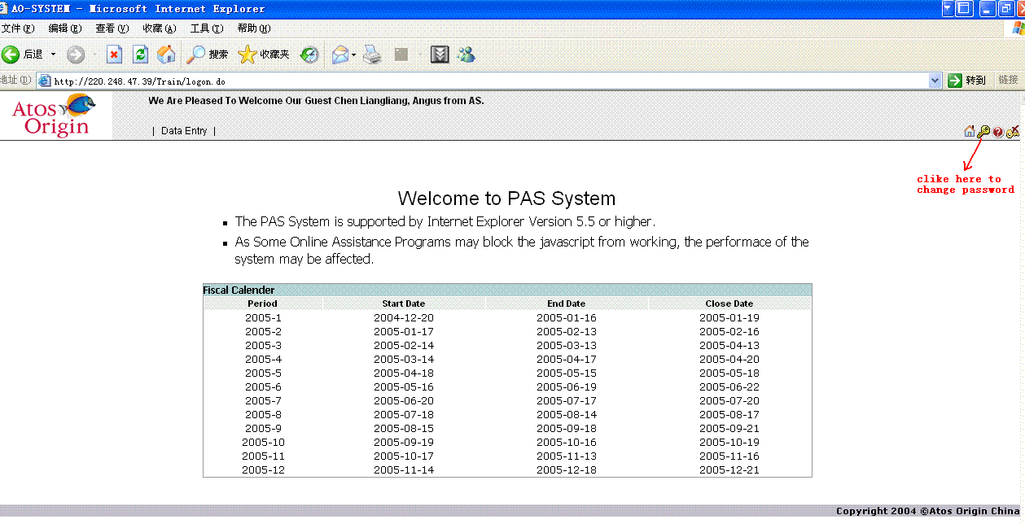
Diagram 2: PAS home page
Please read the information on the home page carefully in order to use the system correctly
- The PAS System is supported by Internet Explorer Version 5.5 or higher;
- As some Online Assistant Programs (such as 3721, google search bar and sohu/sina news bar) may affect the performance of the system, please switch them off by right clicking on the window’s tool bar and un-tick them.
- In the home page also shows the AO fiscal calendar table, it tells user the start date, end date and close date for each fiscal month. The “close date” is the last date for users to key in the time sheet for the corresponding fiscal month.
- All users should be able to see the Data Entry on the menu bar. All daily operations (such as time sheet entry, expense claim and presale activity) are in this menu.

